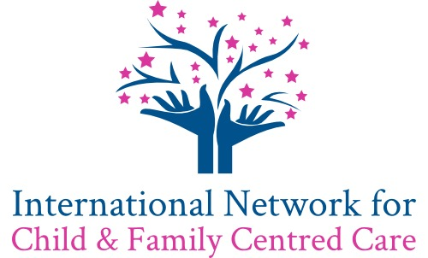

TERMS OF REFERENCE
Version history:
2020-12-11 1.0 Initial Draft
Chairs of INCFCC: Mandie Foster, Sarah Neill and Mohammad Al-Motlaq

Our Vision
The International Network for Child and Family Centred Care (INCFCC) is a vibrant global collaboration of experts in child and family centred care (CFCC). Our members communicate and collaborate in research, practice development and education to identify good practice and develop the evidence base to influence positive change at local and international levels. Our collaborative network aims to achieve this vision by ensuring that children and their families are at the heart of everything we do and through considering the specific challenges of CFCC in different cultures and care settings.

Membership
Membership of INCFCC will be based on expertise and interest in child and family centred care and will be open to all who are researching in the field of child and family centred care and/or applying this evidence base to practice for the benefit of children and families around the world.
Scope of responsibility
INCFCC members have responsibility to:
- respond to requests from INCFCC Co-Chairs within a reasonable timeframe
- generate proposals for new projects
- identify funding opportunities for grant applications
- support scholarly activity of members
- actively engage in research collaborations (locally, nationally and internationally)
- actively engage with the network, to identify new avenues of research, and to share research findings
Meeting frequency
The network will hold a minimum of two meetings for the whole network each year. Individual working groups may meet more frequently as the work involved requires.

Communication
Members agree that between meetings the main method of communication will be email using the email addresses provided within the Membership list. Members are required to keep their email address up to date within the Membership list. Meetings will be held on a video conferencing platform which is accessible to all members without cost to the individual. Microsoft Teams will be used to host all of the documents for the network and for collaborative working.

Terms of Reference
In agreeing to join the International Network for Child and Family Centred Care all members commit to:
- act in a respectful manner towards all members of the network
- respect the intellectual property of the network and its members
  - preserve the confidentiality of ideas generated within the network
  - keep all network details, including all of the information shared on the network database (currently held on Microsoft Teams), confidential, unless it has been agreed with the members concerned that the information can be shared
  - attend at least one meeting each year.
In addition, all members of the network agree that the details that they provide about themselves for the purposes of joining the network (name, email, work address, ORCiD ID, interests in child and family centred care, country and any other details later added to the memberships list) can be shared on the network website.

I have read and agree to these Terms of Reference:

Name:

Date:

Signed:

Please add either a scanned electronic signature then save as a PDF or print, sign and scan and, in both cases upload to MS Teams folder _______________.

